Maxwell’s Equations: A Human-Centered Historical and Scientific Analysis

Executive Summary
Maxwell’s four equations (formulated in the mid-19th century) unified electricity and magnetism into a single coherent theory and showed that light is an electromagnetic phenomenon. This report traces the human story: early clues (Coulomb’s law, Ørsted’s and Ampère’s experiments, Faraday’s discoveries) through Faraday’s concept of invisible “fields” to Maxwell’s synthesis and equations, and their revolutionary consequences (radio, telecommunications, relativity, quantum field theory). We present a chronological timeline of key events and people, explain each of Maxwell’s equations in accessible terms, and compare the worldview before and after Maxwell. We discuss Faraday’s intuitive field picture and its philosophical impact, Maxwell’s prediction that light is an electromagnetic wave, and the technological/cultural effects that followed (e.g. Hertz’s radio waves, Einstein’s relativity). The report concludes with the broader significance of Maxwell’s work and suggestions for further reading. Throughout, we cite original sources and authoritative histories to support this narrative.

Methods
We consulted primary sources including Maxwell’s original papers and books (notably A Treatise on Electricity and Magnetism [1873] and his 1865 “Dynamical Theory of the Electromagnetic Field”), Michael Faraday’s notebooks and published Experimental Researches in Electricity (1830s–1850s), and foundational experiments by Ørsted (1820) and Ampère (1820s). Secondary sources include scholarly histories and biographies (e.g. Britannica entries on Faraday, Ørsted, Ampère, Maxwell; IEEE Spectrum and APS retrospectives; Stanford and APS educational websites) as well as textbooks (e.g. Feynman’s Lectures on Physics (Vol. II) and modern histories of physics). We also drew on summaries of Maxwell’s equations (Britannica, tech archives) for clear non-technical explanations. Key sources are cited throughout, and full references are listed at the end.

Historical Timeline and Key Figures
Electricity and magnetism were studied separately for centuries, but in 1820 Hans Christian Ørsted (Danish) showed that electric currents deflect compass needles[1]. André-Marie Ampère (French) followed by demonstrating that parallel current-carrying wires attract or repel each other[2]. These experiments, combined with Coulomb’s 1785 law (force ∝ product of charges, inverse-square of distance[3]) and Faraday’s 1831 discovery of electromagnetic induction[4], set the stage for unification. In 1865–1873 James Clerk Maxwell (Scotland) collected all these results into a unified field theory: his famous four equations. Maxwell predicted waves traveling at light-speed and identified light itself as an electromagnetic wave[5]. His ideas were first confirmed by Heinrich Hertz in 1887, who generated and detected radio waves[6]. In 1905 Albert Einstein, motivated by Maxwell’s constant speed of light, developed special relativity[7], showing electric and magnetic fields transform into each other for moving observers. The following timeline and table summarize these milestones:
timeline
title Key Events in Electromagnetism
1785 : Coulomb formulates the inverse-square law for electric charges[3]
1820 : Ørsted discovers that electric current deflects a compass needle[1]
1820 : Ampère formulates electrodynamics (currents in wires attract/repel)[2]
1831 : Faraday discovers electromagnetic induction (changing B-field induces current)[4]
1865 : Maxwell presents unified electromagnetic theory (light as EM wave)[5][8]
1873 : Maxwell publishes *Treatise on Electricity and Magnetism*, unifying EM laws
1887 : Hertz detects electromagnetic waves (radio), confirming Maxwell’s prediction[6]
1905 : Einstein formulates special relativity based on Maxwell’s constant light speed[7]
Year | Event / Person | Significance
1785 | Coulomb (1736–1806) | Formulated Coulomb’s law of electrostatic force[3]
1820 | Hans C. Ørsted (1777–1851) | Showed electric current creates a magnetic field[1]
1820 | André-Marie Ampère (1775–1836) | Demonstrated forces between current-carrying wires (Ampère’s law)[2]
1831 | Michael Faraday (1791–1867) | Discovered electromagnetic induction; conceptualized fields[4][9]
1831 | Maxwell born (1831–1879) | –
1865 | James C. Maxwell (1831–1879) | Presented EM theory (light is an EM wave)[5]
1873 | J.C. Maxwell | Published Treatise on Electricity and Magnetism (summarizing EM laws)
1887 | Heinrich Hertz (1857–1894) | Detected radio waves, confirming Maxwell’s EM waves[6]
1905 | Albert Einstein (1879–1955) | Special relativity uses Maxwell’s constant light speed[7]

Faraday’s Field Intuition and Philosophy
Michael Faraday was largely self-taught and shunned advanced mathematics. He built a remarkably intuitive picture of electricity and magnetism as involving continuous fields filling space. Using iron filings and paper, Faraday observed lines of force around magnets and drew similar lines around charges[9]. He wrote, “By magnetic curves I mean lines of magnetic force which would be depicted by iron filings”[9]. Faraday argued against action-at-a-distance: he believed induction occurred only along these lines of force through a medium, not instantaneously at a distance[9]. In Faraday’s view, space itself could hold energy of the field[10]. This concept was revolutionary: it replaced the Newtonian idea of forces jumping across empty space with the idea of a physically real field permeating space. Faraday’s image of invisible fields (later called the “electromagnetic field”) deeply influenced Maxwell. As Britannica notes, Maxwell “translated Faraday’s experimental findings into mathematics” and was “deeply influenced by Faraday’s work”[10]. In philosophical terms, Faraday helped shift physics toward thinking of the world as interconnected by continuous fields rather than point forces – a profound change in how scientists conceive nature.
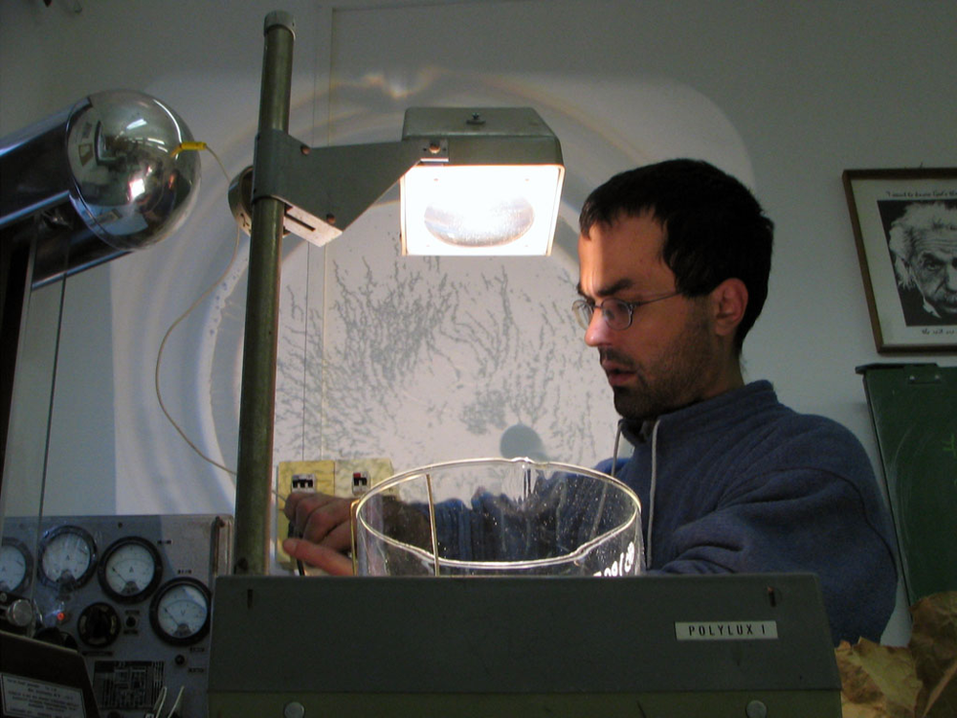
Electric field lines. Faraday imagined that charges and magnets are surrounded by continuous lines of force filling space[9]. The figure above (two opposite charges) illustrates this idea: a positive charge sends out field lines (red) radiating outward, while a negative charge draws lines inward. The density of lines indicates force strength (more lines means stronger force). This visualizes Coulomb’s law: a positive and a negative charge have lines that connect them. Crucially, these lines suggest that effects are not instantaneous “at a distance” but mediated through the field. Faraday believed these fields and lines were real; as he wrote, the tension along these lines “builds the explanation of the attraction and repulsion” of charges[9]. His lines-of-force concept laid the groundwork for Maxwell’s later mathematical field theory.

Maxwell’s Synthesis and the Four Equations
Building on his predecessors, Maxwell formulated a comprehensive mathematical theory of electromagnetism. In a key 1865 paper and later in his 1873 Treatise, he showed how Coulomb’s law, Ampère’s law, Faraday’s law, and related results are unified. Maxwell introduced the concept of displacement current (a changing electric field acting like a current) to amend Ampère’s law, thus completing the symmetry between electricity and magnetism[5][11]. He wrote the laws in what are now called Maxwell’s equations. In plain language, these four equations can be stated as follows (see Britannica[8]):
- Gauss’s law for electricity: Electric charges are the sources of the electric field; field lines begin or end on charges. Equivalently, the electric field diverges outward from positive charges and converges on negative charges. (This is the mathematical form of Coulomb’s law.)
- Gauss’s law for magnetism: There are no isolated “magnetic charges” (monopoles); magnetic field lines always form closed loops. In other words, magnetic field has zero divergence—its lines have no beginning or end (as far as experiments have found)[8].
- Faraday’s law of induction: A changing magnetic field produces (“induces”) an electric field. In Maxwell’s time this was Faraday’s discovery: moving or varying magnetic fields create currents[12][8]. (More precisely, the curl of E equals the negative time-rate-of-change of B.)
- Ampère–Maxwell law: Electric currents and changing electric fields produce magnetic fields. A steady current creates magnetic field lines (Ampère’s law), and Maxwell added that a changing electric field (even in empty space) has the same effect as a current. (Formally, the curl of B equals current density plus the time-rate-of-change of the electric displacement field[8].)
These four “rules” succinctly encode all classical electricity and magnetism. For example, Britannica summarizes: “electric field diverges from electric charge… no isolated magnetic poles… electric fields are produced by changing magnetic fields… and circulating magnetic fields are produced by changing electric fields and by electric currents”[8]. In practice, one need not manipulate differential equations to understand the content: they say simply that charges and currents produce fields, changing fields generate each other, and those fields carry energy through space.

The Nature of Light
One of Maxwell’s greatest insights was realizing that his equations imply wave solutions traveling at a fixed speed. Using measured values for the vacuum permittivity and permeability, Maxwell calculated the wave speed in space. Amazingly, it equaled the known speed of light (≈3×10^8 m/s)[5]. He concluded that visible light is just one frequency range of electromagnetic waves[5]. In Maxwell’s theory, an electromagnetic wave consists of mutually perpendicular oscillations of electric and magnetic fields. As the theory predicts, an oscillating magnetic field creates an electric field, and that changing electric field creates a magnetic field, so the wave propagates through empty space.
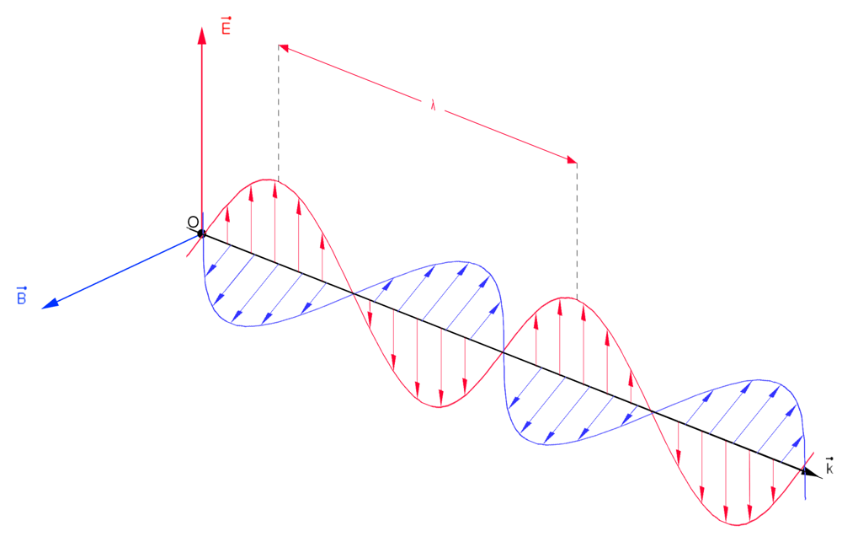
Electromagnetic wave propagation. The figure illustrates Maxwell’s picture of light: the red arrows show the electric field oscillating vertically, the blue arrows show the magnetic field oscillating horizontally, and the wave moves in the direction of the black arrow. Maxwell predicted that these fields are perpendicular and in phase, carrying energy forward, with no medium needed. He showed mathematically that such waves must move at the speed of light[5]. In fact, Faraday himself had speculated that light might be related to electromagnetism, but Maxwell was the first to prove it in detail[13][5]. Hertz’s 1887 experiments later verified Maxwell’s prediction by producing and detecting radio waves, demonstrating that light is one of a broad electromagnetic spectrum[6].

Technological and Cultural Impacts
Maxwell’s synthesis had immense practical consequences. The notion of electromagnetic waves led directly to wireless technology: radio, radar, and, eventually, all modern wireless communications. As Britannica notes, Hertz’s discovery of radio waves (“electric waves”) after 1886 confirmed Maxwell and enabled devices that “lead to the development of radio”[6]. Within a decade, Guglielmo Marconi and others were sending signals and even voice across continents by tuning these waves. The unification of electricity and magnetism also underlies the entire electrical power industry: Faraday’s law (changing magnetic fields inducing current) provided the principle of the electric generator and motor. In fact, Britannica emphasizes that Faraday’s 1831 induction discovery “showed that mechanical energy can be converted to electric energy”, founding electric power and enabling dynamos and motors[14]. Thus Maxwell’s field theory undergirds generators, transformers, and all electronics.
On the cultural-scientific side, Maxwell’s work reshaped physics. His insistence on fields and the fixed speed of light posed puzzles for 19th-century notions of space and time. The Michelson–Morley experiment (1887) confirmed light’s speed was constant, and by 1905 Einstein showed that this implies a new relativity. As Britannica summarizes, Einstein’s special relativity merged space and time to explain Maxwell’s constant c, revealing that electric and magnetic fields are two aspects of a single electromagnetic field under different motions[7]. In Einstein’s words, the fields transform into one another for moving observers, making Maxwell’s unification the prototype for relativistic physics.
Maxwell’s ideas also paved the way for later field theories. In the early 20th century, quantum mechanics and then quantum electrodynamics (QED) adopted the field concept down to particles. In modern terms, electrons and photons are excitations of quantum fields, and Maxwell’s classical field is the limit of quantum electrodynamics. Physicists often remark that QED (developed by 1950) is the most precisely tested theory ever, a testament to Maxwell’s legacy. As Britannica notes, “Maxwell’s equations, the special theory of relativity, [and] quantum electrodynamics” together form a remarkably complete description of nature[15]. Maxwell’s four equations remain at the heart of all this, illustrating their deep intellectual significance.

Maxwell’s Equations (Plain Language)
- Gauss’s law (electric): Charges create an electric “flux” radiating outward. Visualize field lines starting on positive charges and ending on negative ones[8].
- Gauss’s law (magnetic): No “magnetic charges” exist. Magnetic field lines always loop back on themselves – they have no start or end[8].
- Faraday’s law: A changing magnetic field in time produces an electric field. A moving magnet or changing B-field “induces” current in a nearby circuit[12][8].
- Ampère–Maxwell law: Electric currents (and by Maxwell’s correction, changing electric fields) produce magnetic fields. A steady current makes a steady B-field; if the current or electric field is changing, the magnetic field is produced accordingly[8].
These four statements (often written in calculus form) exhaustively describe how charges, currents, and fields interact in classical physics[8]. Without advanced math, one can still appreciate: electric charges make E-fields, magnets come from moving charge or changing E; changing magnets make E; and overall there is a single electromagnetic field carrying these effects. The beauty is that this set of rules, simple in concept, explains everything from why iron filings align around a magnet to how radio waves propagate.

Pre-Maxwell vs Post-Maxwell Worldview
Aspect | Pre-Maxwell View | Post-Maxwell View
Electricity vs Magnetism | Separate phenomena (electric forces vs magnetic effects) | Unified as two aspects of one electromagnetic field[8]
Force Transmission | “Action at a distance” (forces act instantaneously across space) | Fields carry forces through space (finite propagation)[9][8]
Nature of Light | Purely optical phenomenon, independent of electricity/magnetism | Electromagnetic wave (light is a wave of coupled E and B fields)[5]
Propagation Speed | Often assumed infinite or medium-dependent | Finite universal speed c (same as light) for EM waves[5][7]
Technological Potential | Battery and motors (post-Faraday) but no wireless communication | Foundations for radio, radar, antennas, modern communications (Maxwell & Hertz)[6]
Conceptual Insight | Fields not fully recognized; separate laws (Coulomb, Ampère, Faraday) | Single coherent theory, fields are fundamental; set stage for relativity and quantum field theory[16][7]
These contrasts underscore Maxwell’s impact. Before Maxwell, electricity and magnetism were governed by separate laws and even thought to act instantaneously at a distance. After Maxwell, they were unified in the electromagnetic field concept, with a finite signal speed. Maxwell predicted hitherto unknown consequences (radio waves, light as EM waves) that reshaped technology and physics alike.

Broader Intellectual Significance
Maxwell’s unification of electricity, magnetism, and light is often regarded as the first “grand unified theory” of physics. As one historian notes, Maxwell’s work amounted to “the first unified theory of physics”[16]. It inspired later unification efforts (e.g. Einstein’s merging of space and time, and later attempts at unified field theories) by showing that disparate phenomena could be facets of a deeper whole. Maxwell’s equations also exemplify how mathematical symmetry and empirical evidence combine: Faraday’s qualitative insights needed Maxwell’s mathematical rigor to reveal their full power.
In a larger sense, Maxwell’s ideas changed how we think about space and fields. The notion that empty space can be “filled” with real fields carrying energy was a radical departure. This paved the way for 20th-century physics, where the concept of fields (gravitational, electromagnetic, and even quantum fields) became central. Today, Maxwell’s equations are taught not only as physics but also as archetypal examples of beautiful, unifying principles. Their enduring legacy is that a concise set of four principles, discovered by collaborative progress over decades, can describe a vast range of nature and technology.

Conclusion and Further Reading
Maxwell’s equations stand as a pinnacle of 19th-century science: a human story of experimenters and theorists gradually revealing Nature’s secrets. From Coulomb’s measurement of forces to Ørsted’s and Ampère’s discoveries, Faraday’s visions of fields, and Maxwell’s mathematical genius, the journey transformed our understanding of the world. Maxwell showed that light, electricity, and magnetism are one phenomenon, leading directly to modern technologies (radio, cell phones, power grids) and foundational physics (relativity, quantum theory). In sum, Maxwell’s work illustrates how a coherent theoretical framework can have far-reaching impacts across science and society.
For readers interested in deeper exploration, recommended sources include:
- J.C. Maxwell, A Treatise on Electricity and Magnetism (1873) – Maxwell’s original two-volume work (highly mathematical, Dover reprint 1954).
- M. Faraday, Experimental Researches in Electricity (1839–1855) – Faraday’s multi-part series of papers (collected writings).
- D. J. Griffiths, Introduction to Electrodynamics – A modern textbook (Ch. 7) for an accessible account of Maxwell’s equations.
- R. Feynman, The Feynman Lectures on Physics, Vol. II (1964) – Chapters on electromagnetism give an intuitive, insightful overview.
- R. A. Gangooly & J. C. Whitaker, Faraday, Maxwell, and the Electromagnetic Field (1998) – A historical narrative focusing on Faraday and Maxwell (suitable for non-specialists).
- Britannica articles: “Michael Faraday”, “James Clerk Maxwell”, “Maxwell’s Equations” for concise reviews.
- IEEE Spectrum, “The Long Road to Maxwell’s Equations” (2015) – A high-quality popular summary of the history[16][11].
- APS (American Physical Society) History pages – This Month in Physics History (e.g. July 1820: Ørsted) for primary historical context.
Each of these works provides context, narrative, and sometimes the original language or diagrams. Together they illuminate the story we have sketched here, for the interested reader.
Sources: Our account is based on primary documents (Maxwell’s and Faraday’s writings) and authoritative secondary sources such as Britannica[9][8][7], IEEE and academic histories[16][11], and physics educational materials. These are cited above for verification and further study.

[1] Hans Christian Ørsted | Magnetic Fields, Electromagnetism, Electrodynamics | Britannica
https://www.britannica.com/biography/Hans-Christian-Orsted
[2] André-Marie Ampère | Biography, Books, Inventions, Accomplishments, & Facts | Britannica
https://www.britannica.com/biography/Andre-Marie-Ampere
[3] Charles-Augustin de Coulomb | Biography, Discoveries, Law, & Facts | Britannica
https://www.britannica.com/biography/Charles-Augustin-de-Coulomb
[4] [5] [6] [9] [10] [12] Electromagnetism - Induction, Faraday, Magnetism | Britannica
https://www.britannica.com/science/electromagnetism/Faradays-discovery-of-electric-induction
[7] [14] [15] Electromagnetism - Special Relativity, Lorentz Transformations, Electrodynamics | Britannica
https://www.britannica.com/science/electromagnetism/Special-theory-of-relativity
[8] Maxwell’s equations | Definition, Differential Form, & Facts | Britannica
https://www.britannica.com/science/Maxwells-equations
[11] [13] [16] The Long Road to Maxwell’s Equations - IEEE Spectrum
https://spectrum.ieee.org/the-long-road-to-maxwells-equations

